**Automated traffic monitoring system using computer vision:**

**Summary:**

**Abstract:**

* A system has been developed that uses Traffic Surveillance video input from a camera to count the number of vehicles and speed limit violators and penalize offenders to reduce traffic offences.
* The system has a vehicle count accuracy of 98.96% and a speed violation detection accuracy of 98.14%.
* We use the concept of Multiple Reference Lines to examine how long it takes a vehicle to cross the reference lines in total duration of frames.

**Introduction:**

* Traffic violation is a problem and therefore accidents occur, and aim is to decrease the number
* Radar guns are used, but they can’t target short- range and detect multiple vehicles
* Computer Vision technology replaces humans which improves efficiency in finding the violators
* Counting number of vehicles gives us data regarding the traffic scenario in a particular area which can be used for management of the traffic by understanding the traffic
* Cameras are positioned to have a top view and the algorithm gives a cropped image of the violators
* Cameras need a capital to setup, but they are much durable than the passive sensors
* Passive sensors are placed directly on the pavements
* Cameras provide flexibility, better durability, efficiency, and profitability.

**Related Work:**

* **Model-Based Tracking:** Proposed by Dieter Koller
* This method uses Parameterized vehicle model for an intraframe matching strategy
* The image segmentation component identifies potential moving vehicles by classifying the image's moving features
* **Region Based Tracking:** This technique tries to find the connected regions in an image with each vehicle and tracks them (Used Background Subtraction Technique). This fails when there is a congestion and vehicles occlude.
* **Kalman Filter Approach:** Helps to know the background i.e., lightning, time changes and Weather changes
* **Active-Contour Approach:** Uses tracking of active contour models, Decreased computational complexity
* **Tracks Sub-Features:** Even when partial occlusion occurs, some features are noticeable
* **Jaesik Choi & Sungji Han:** They used a Haar like features, which considers adjacent rectangular regions and sums up the pixel intensities, and then takes their difference. This is used for classification of image.
* **Artificial Neural Networks:** Decisions are based on previous knowledge
* **Hybrid Systems**

**Proposed System:**

* **Three Stages:**
  + **Pre-Processing:**
    - Two Reference lines are set for each video
    - The green lines in the below diagram represents the reference lines being used
    - The color of the reference lines of first frame are stored

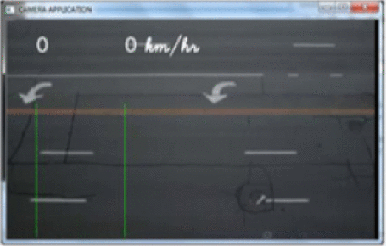

* + **Vehicle Count Detection and Speed Estimation:**
    - When a car passes the first green line then the pixel value of the line changes and thus indicating a crossing of a vehicle, from this we can find the count.
    - We get the frame number when a vehicle exists a reference line i.e., by checking when the first green reference line turns back to its original state or color.
    - Using above step, we find both when the vehicle crosses 1st reference line and 2nd reference line



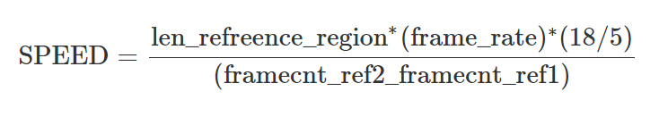



**\*\*As len_reference_region is in meters we convert that to km i.e., we convert m/sec to km/hr by multiplying m/s with (18/5) km/hr \*\***

**Speed –** Speed of vehicle in km/hr.

**len_reference_region –** Length of the road between the two reference lines (in meters)

**frame_rate –** Rate at which the video is being played

**framecnt_ref1 –** Frame count at which the vehicle exists the first reference line

**framecnt_ref2 –** Frame count at which the vehicle exists the second reference line

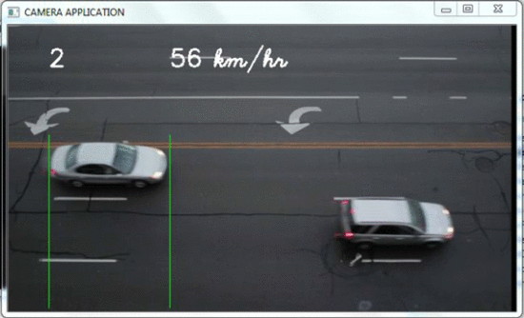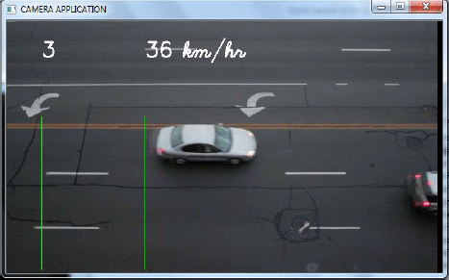

* + **Speed Violation Detection:**
    - Speed limit set for this was 40km/hr and length of the road was estimated to be 5.6 meters (i.e., the distance between the reference lines) to effectively calculate speed

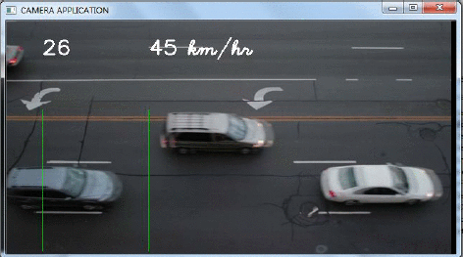

The speed of the above car is more than 40 km/hr

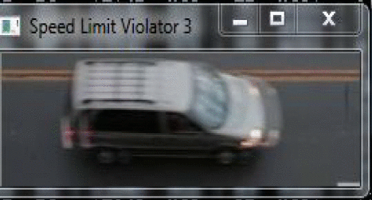

And the cropped image of the traffic violator is presented above

* + **Adapting to various light conditions:**
    - As the lighting conditions change throughout the day, The system can notice changes in the RGB values and adapts to the new RGB values, thus is consistent with the lighting conditions.
* **Algorithms used for Vehicle count and Traffic violators:**

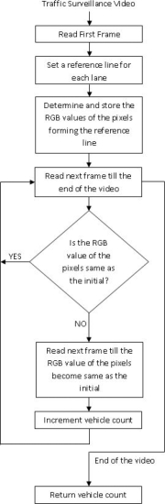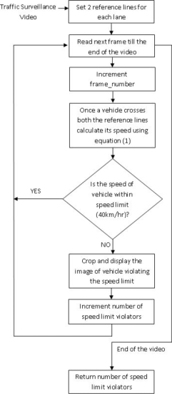

* **Experimental Results:**
  + For efficiency Visual Studio was used and tested on freeway surveillance video files

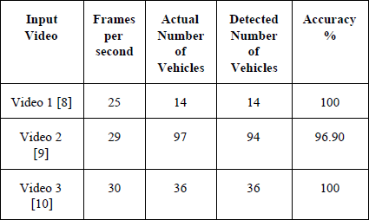

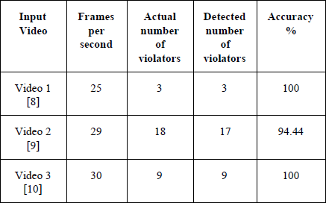

* **Website for Reference:**

<https://ieeexplore-ieee-org.ezproxy1.lib.asu.edu/document/7892717>